**Look & Feel**

* Primary colors should include Black, Tan and Forest Green
* The vibe should be dark but chill with kind of the same layout as the Susan Rigg site. The above tabs would include 'Home' 'About' 'Social Media Management' and 'Fashion Styling' 'Rights Management' (It would be nice to include the Call-to-Action 'Work with me' as well if possible)
* Layout will mimic that of my portfolio

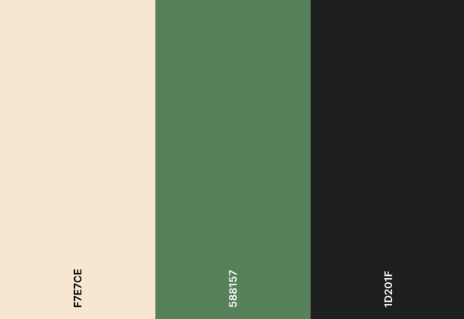

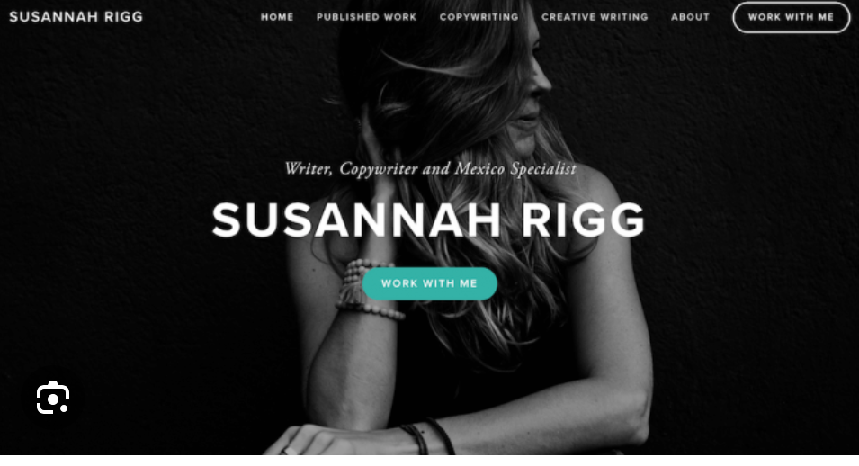

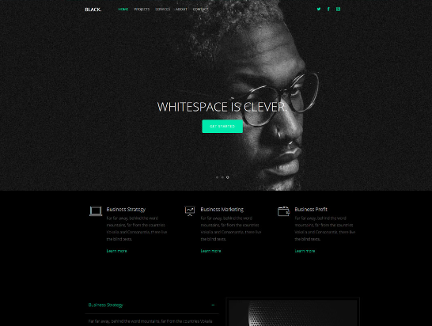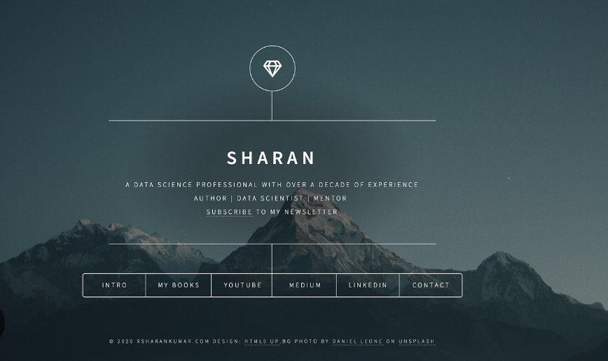

**Content**

* **About**

| Originally from Chicago,IL USA I moved to Japan in 2017 where  I worked as an English teacher for three years before transitioning into the creative arts field. Through my exploration I discovered my true calling: Fashion Styling and Social Media Management.  I have participated in various internships and styling apprenticeships in order to gain practical experience including Tokyo Start-ups such as Future Foundation(NPO) and Oigetit Inc. as well as features in Schon Magazine and Korean fashion brand IHNN  I am highly motivated, detail-oriented, and my proficiency in both English and Japanese allows me to effectively communicate and connect with a broad range of audiences. |
| --- |

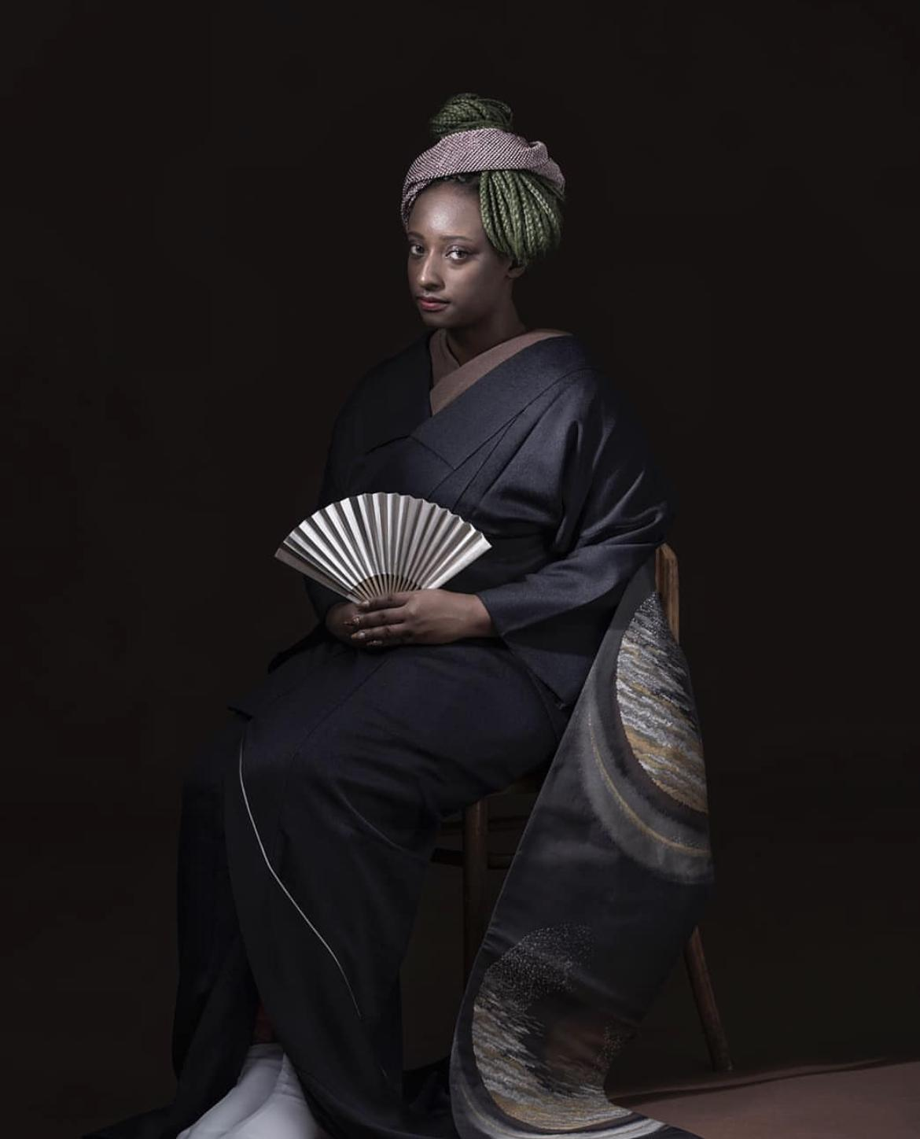I'm thinking we can keep this page simple with just the photo and the brief bio

* **Social Media Management**

This would be a direct copy of what I have in my portfolio as a person would scroll down and they would see what I've done starting with Future. Additional photos of my work can be found in the file. I also want to include my brand book that i'll give you (once i develop it) so that people who are interested in my services can see the pricing. I want them to be able to download it from the site.

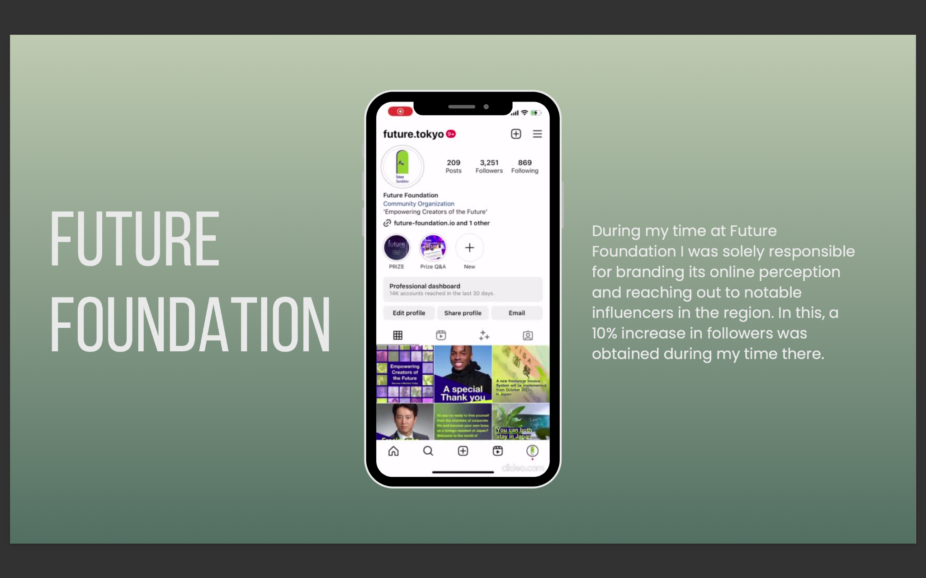

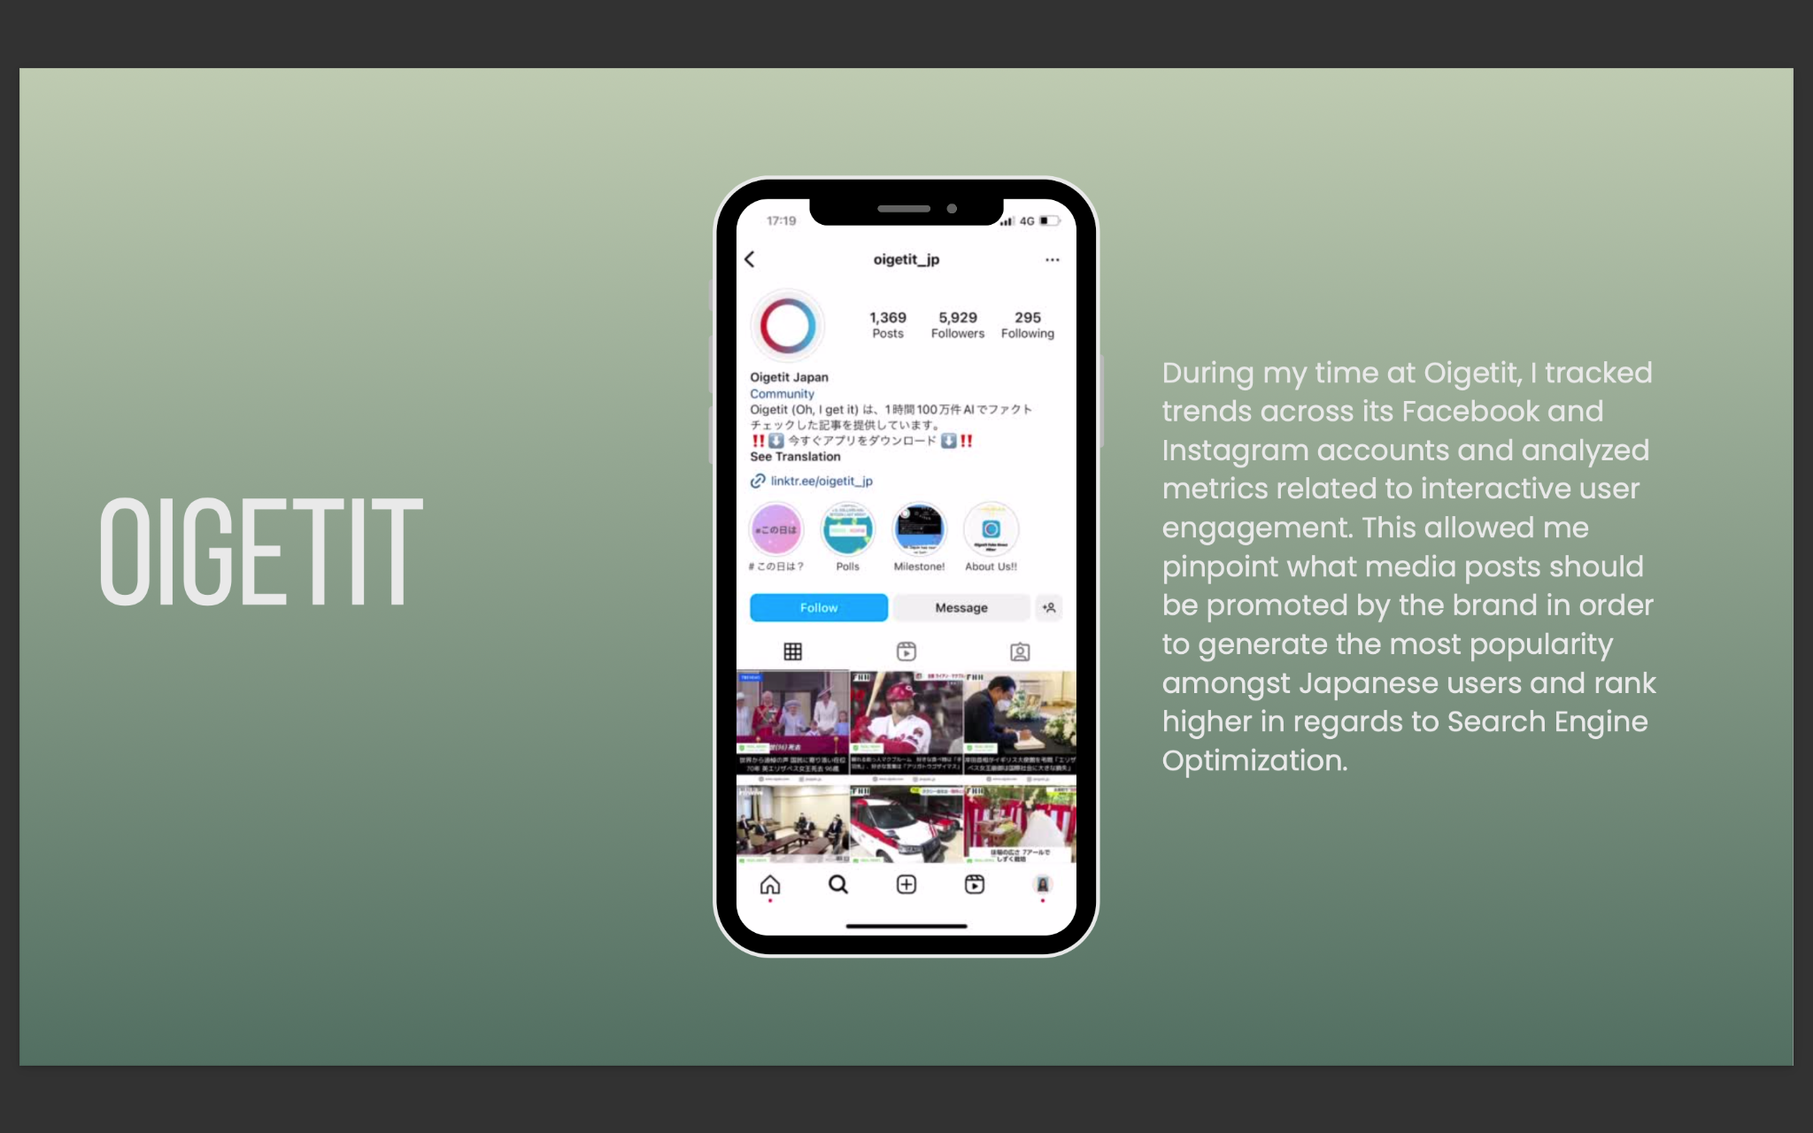

* **Fashion Styling (135 TKY)**

When the user clicks on the Fashion Styling tab I want it to look a little different. The top should say 135 TKY which is my styling name in a sense. Same as my Social Media Management, this would be similar to what I have in my portfolio. As the user scrolls down they would see my work and a little info about the particular shoot they are viewing. Additional photos of my work can be found in file



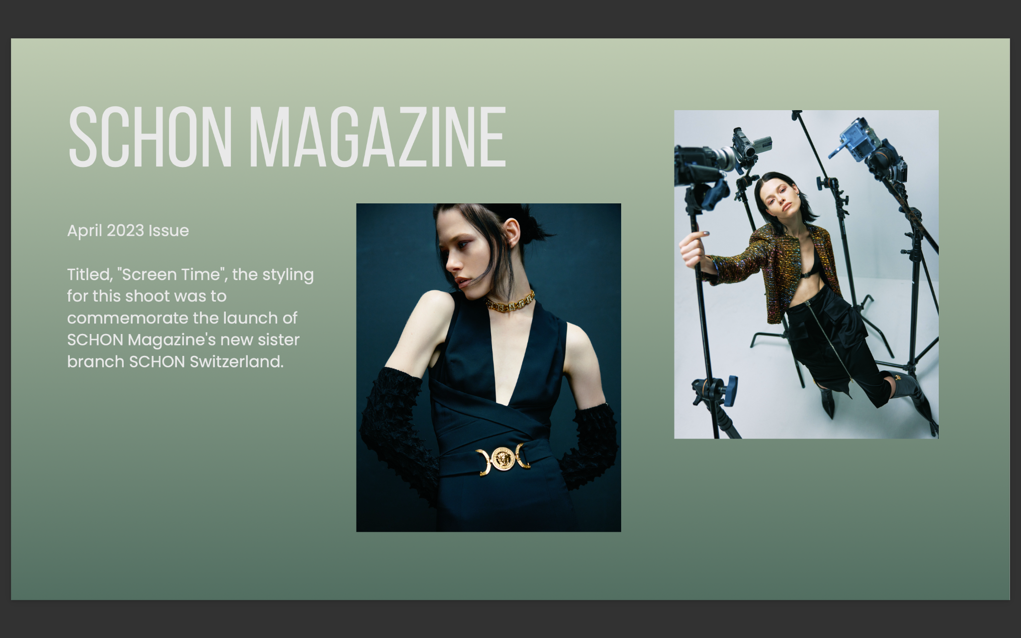

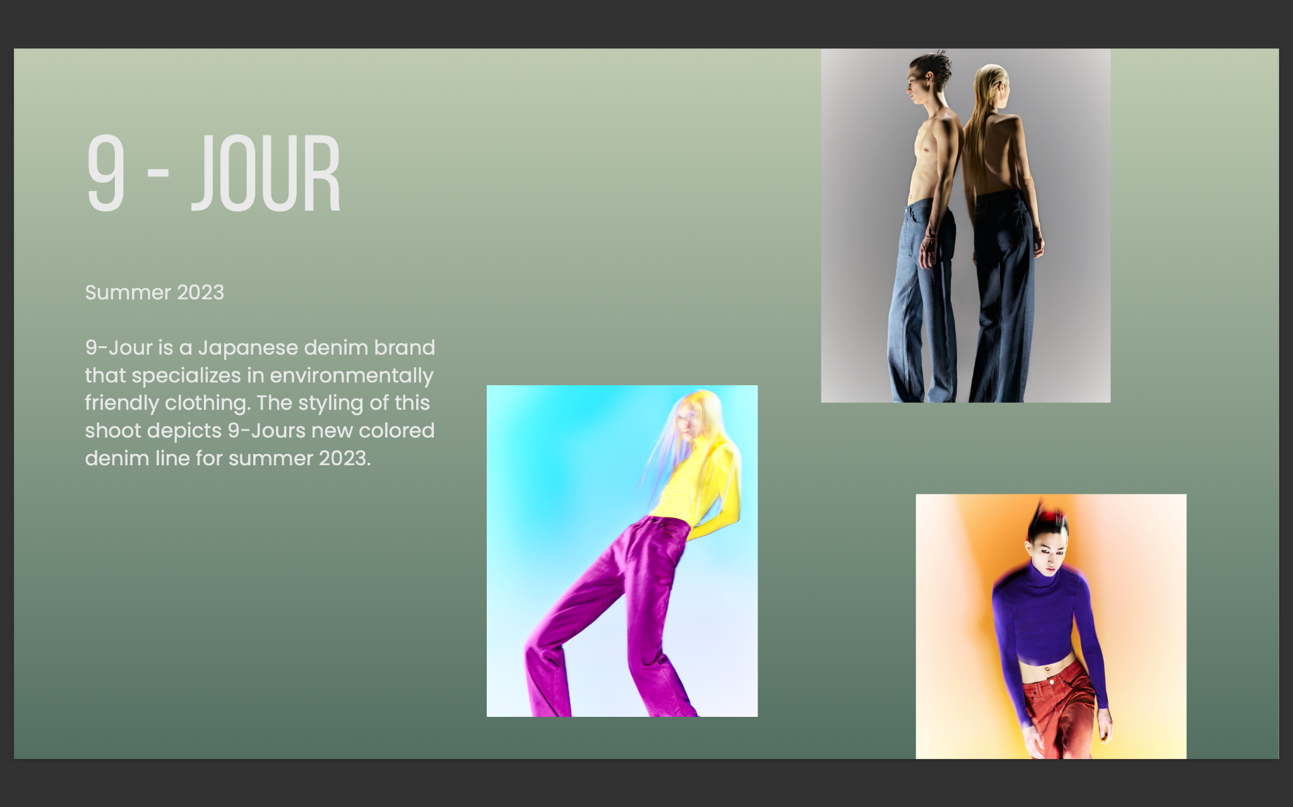

* **Rights Management**

This section needs to be developed a bit maybe together but I want this section to reflect the skills and work I did at this previous company which includes rights (music royalties) management for foreign performers in Japan such as Twice, Shawn Mendes, The Beatles etc.. I'm thinking this would be broken down into two supplementary tabs, Contract Negotiations and Royalty Collections. Because a lot of the work I did was sensitive I'm not even sure if I can show anything but maybe I can just talk about it? IDK

* **Contact**

I need Contact Info so I want to include my email and linkedIn

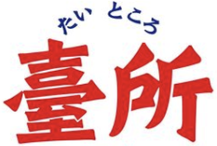 Daitokoro Ishinabde